IT13: ADBMS
Chapter 2:SQL
Practice Assignment Solution Template

Write a query and paste a screenshot of your output below the question.
- Create a database named CompanyDB.
Solution:
create database CompanyDB;
use CompanyDB;
show databases;
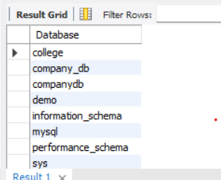

- Create a table Employees with the following columns:
Employees (EmpID (Integer, Primary Key), EmpName, Salary, JoinDate )
Solution:
create table Employees(EmpID int, Primary Key(EmpId), EmpName varchar(20), Salary int, JoinDate date);
desc Employees;
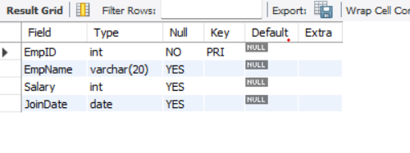
- Create a table Departments with:
Departments (DeptID (Integer, Primary Key), DeptName)
Solution:
create table Departments(DeptId int,primary key(DeptId), DeptName varchar(20));
desc Departments;
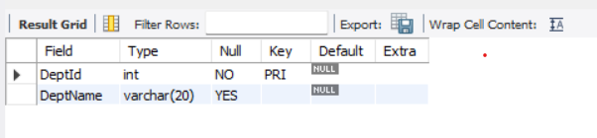
- Add a column Email (VARCHAR(100)) to the Employees table.
Solution:
alter table Employees add Email varchar(100);
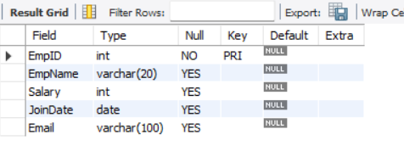

- Add a column dept_location to the Departments table.
Solution:
alter table Departments add DeptLocation varchar(100);
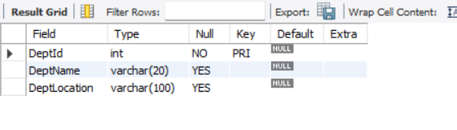

- Add a NOT NULL Constraint to the Phone column
Solution:
alter table Employees add Phone int NOT NULL;
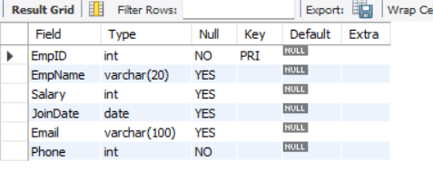

- Change the size of the EmpName column from VARCHAR (50) to VARCHAR (100).
Solution:
alter table Employees modify EmpName varchar(100);
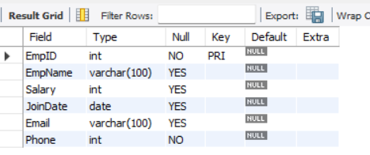

- Drop the primary key Constraint from Departments
Solution:
alter table Departments drop primary key;
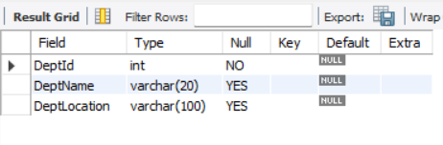
- Create a foreign key constraint between two tables
Solution:
alter table Departments add EmpID int;
alter table Departments add constraint fk_key foreign key(EmpID) references Employees(EmpID);
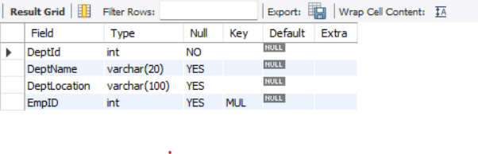
- Rename the column EmpName to EmployeeName.
Solution:
alter table Employees rename column empName to EmployeeName;
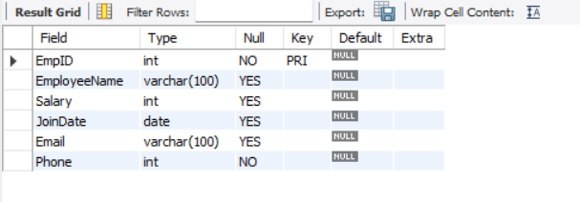
- Apply a CHECK constraint on the Age and Salary columns.
Solution:
alter table Employees add Age int,add constraint chk_1 check(Salary>5000 and Age>18);
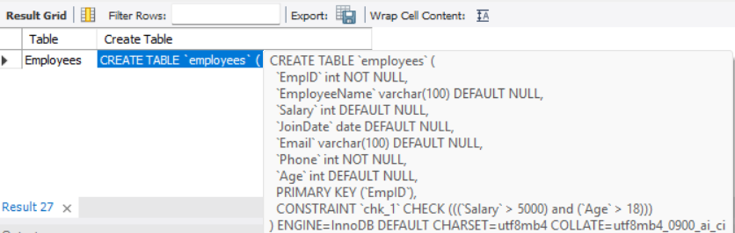

- Remove the Phone column from the Employees table.
Solution:
alter table Employees drop column Phone;
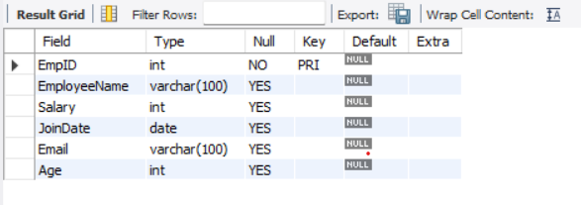
- Rename the table Employees to EmployeeDetails.
Solution:
alter table Employees rename EmployeeDetails;
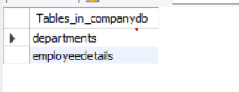

- Drop the CHECK constraints.
Solution:
alter table EmployeeDetails drop check chk_1;
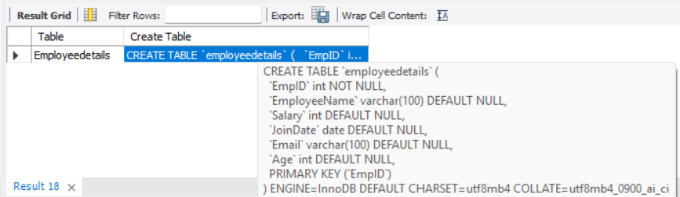

- Delete the Departments table permanently.
Solution:
drop table Departments;
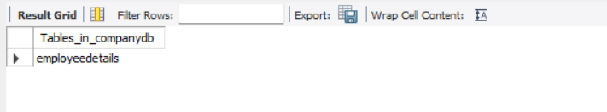

- Drop the database.
Solution:
drop database CompanyDB;
